

# Practices for Secure Software Report

Table of Contents

Practices for Secure Software Report 1

Table of Contents 1

Document Revision History 2

Client 3

Instructions 3

Developer 3

1. Algorithm Cipher 4

2. Certificate Generation 6

3. Deploy Cipher 6

4. Secure Communications 7

5. Secondary Testing 7

6. Functional Testing 8

7. Summary 9

8. Industry Standard Best Practices 9

9. References 9

## Document Revision History

| **Version** | **Date** | **Author** | **Comments** |
| --- | --- | --- | --- |
| **1.0** | **02/25/2024** | **Kemal Cankurt** |  |

## Client



## Instructions

Submit this completed practices for secure software report. Replace the bracketed text with the relevant information. You must document your process for writing secure communications and refactoring code that complies with software security testing protocols.

* Respond to the steps outlined below and include your findings.
* Respond using your own words. You may also choose to include images or supporting materials. If you include them, make certain to insert them in all the relevant locations in the document.
* Refer to the Project Two Guidelines and Rubric for more detailed instructions about each section of the template.

## Developer

Kemal Cankurt

## Algorithm Cipher

Artemis Financial must prioritize the selection of an encryption algorithm that ensures the highest security for their long-term archive files. Choosing a cipher that provides vigorous security, complies with current regulations, and aligns with industry best practices is imperative. Moreover, the chosen algorithm should be dynamic, considering the present security standards and anticipating future challenges.

For the encryption of Artemis Financials' archive files, AES-256 with a 256-bit key is an optimal choice. This encryption algorithm is widely recognized for its robustness and efficiency in safeguarding sensitive data. Also, AES-256 is an integral component of the Java Cryptography Architecture (JCA) within the Java Security Standard Algorithm Names, further enhancing its credibility and reliability in data protection.

The strength of AES-256 lies in its ability to resist a wide range of threats, making it an optimal choice for safeguarding financial data. This encryption standard has been rigorously tested and proven to be highly resistant against practical attacks, including brute force attacks or side-channel attacks. By utilizing AES-256, financial institutions can fortify their security measures and mitigate the risks associated with unauthorized access or data breaches.

The primary risk linked to AES-256 is tied to the effective management of encryption keys. The encryption can be compromised without proper security measures for handling these keys. To mitigate the risk, it is imperative to implement a secure key management system that guarantees the protection and integrity of the encryption.

AES-256 has been designed to comply with the encryption standards mandated by various government and industry regulations. This robust encryption algorithm has also gained the approval of the National Institute of Standards and Technology (NIST) for its use in securing classified information within the U.S. government. By adhering to these regulations and standards, AES-256 ensures the confidentiality and protection of sensitive data.

Offering a comprehensive encryption solution, AES-256 meets data requirements that have been achieved and are in transit. It excels in securing stored archive files, ensuring their confidentiality, and preventing unauthorized access. Moreover, AES-256 proves its worth in file transfers between locations, guaranteeing the protection of sensitive information during transit. Its versatility is a crucial advantage, allowing for easy integration into various software and hardware solutions and making it a valuable tool for organizations aiming to enhance their data security measures.

Although AES-256 is the suggested approach, it has its own disadvantages. To begin with, in scenarios where computational power is limited, AES-256 encryption and decryption may experience decreased efficiency compared to algorithms with shorter key lengths like AES-128. The disparity in performance arises from the fact that AES-256 employs a longer key length, which requires more intricate calculations during the encryption and decryption processes. Consequently, the additional computational workload on systems with constrained computational capabilities can result in a slower encryption and decryption process.

By utilizing a block cipher algorithm with a key size of 256 bits, AES-256 significantly enhances security measures, ensuring a formidable defense against potential attacks. Although hash functions are not inherently incorporated into AES, they hold immense importance in the overall encryption process, particularly when creating and validating encryption keys.

The U.S. government officially adopted AES, marking it the preferred encryption standard. This decision replaces the Data Encryption Standard (DES) published in 1977. AES operates on a symmetric key algorithm, ensuring that the same key is utilized for both the encryption and decryption processes.

NIST founded AES in 2001 to determine a replacement for the outdated DES (Data Encryption Standard). Over time, AES has emerged as the universally accepted standard for ensuring secure encryption on a global scale. Notably, AES-256 has gained recognition for its remarkable blend of efficiency and security, making it the preferred option for official organs where data security is vital.

## Certificate Generation

Insert a screenshot below of the CER file.

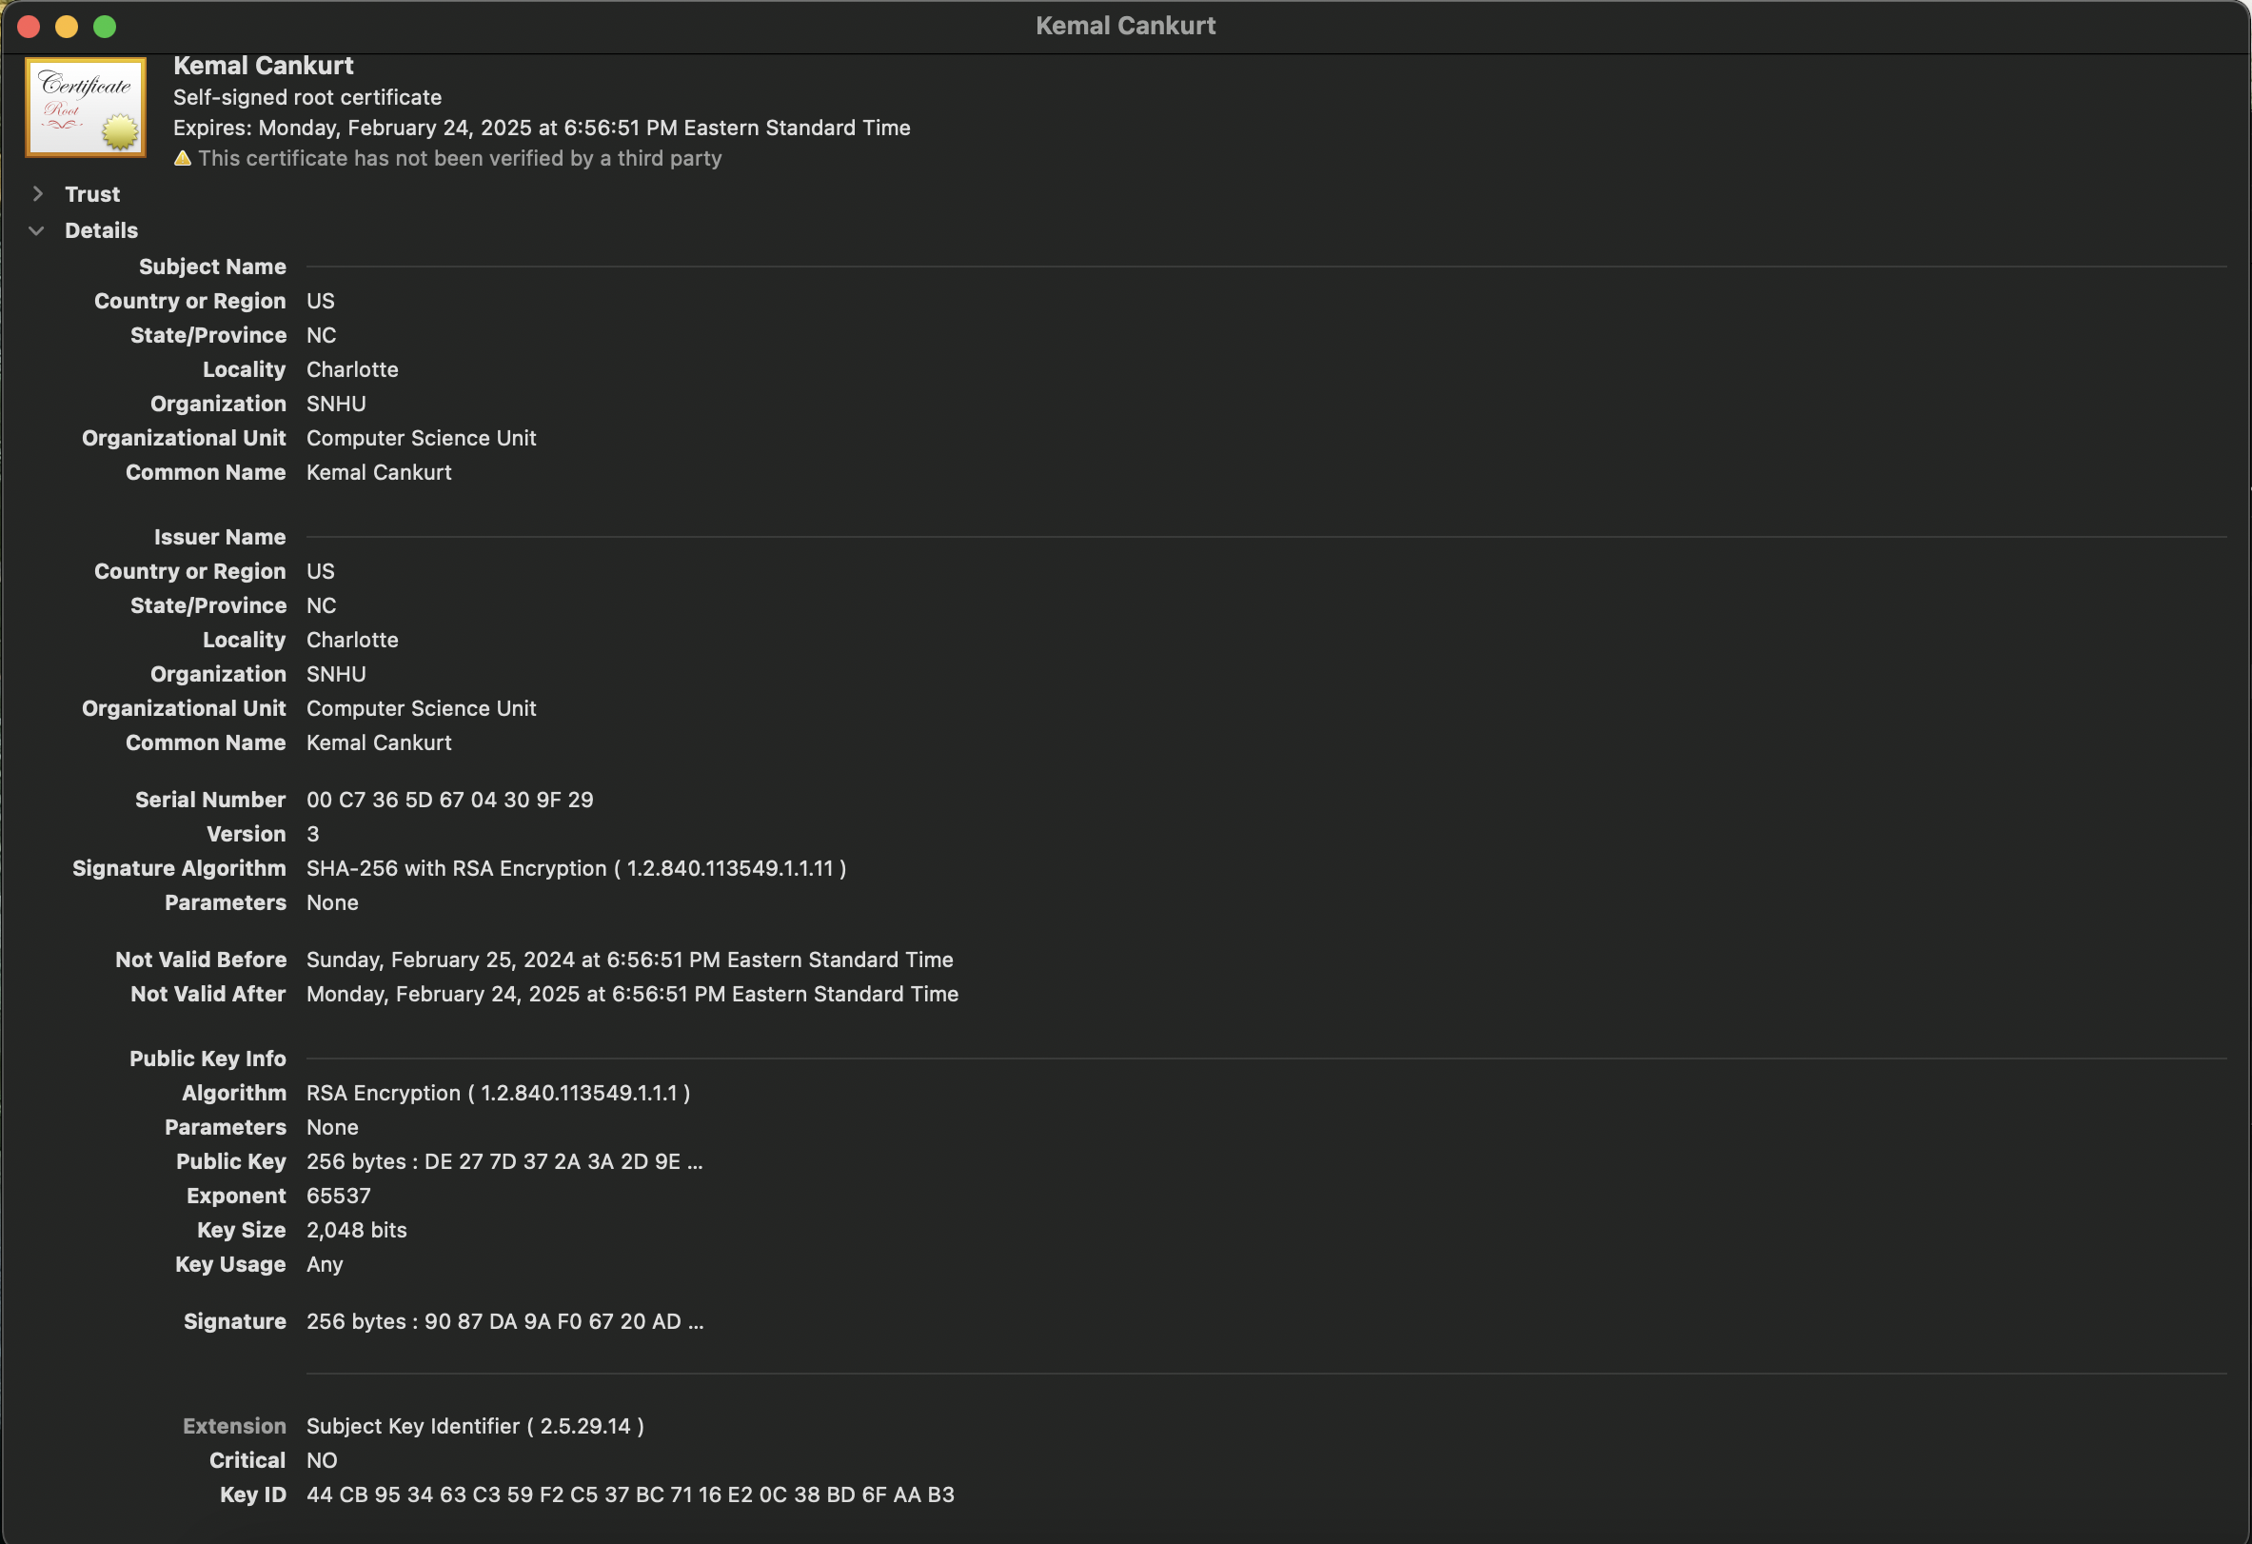

## Deploy Cipher

Insert a screenshot below of the checksum verification.

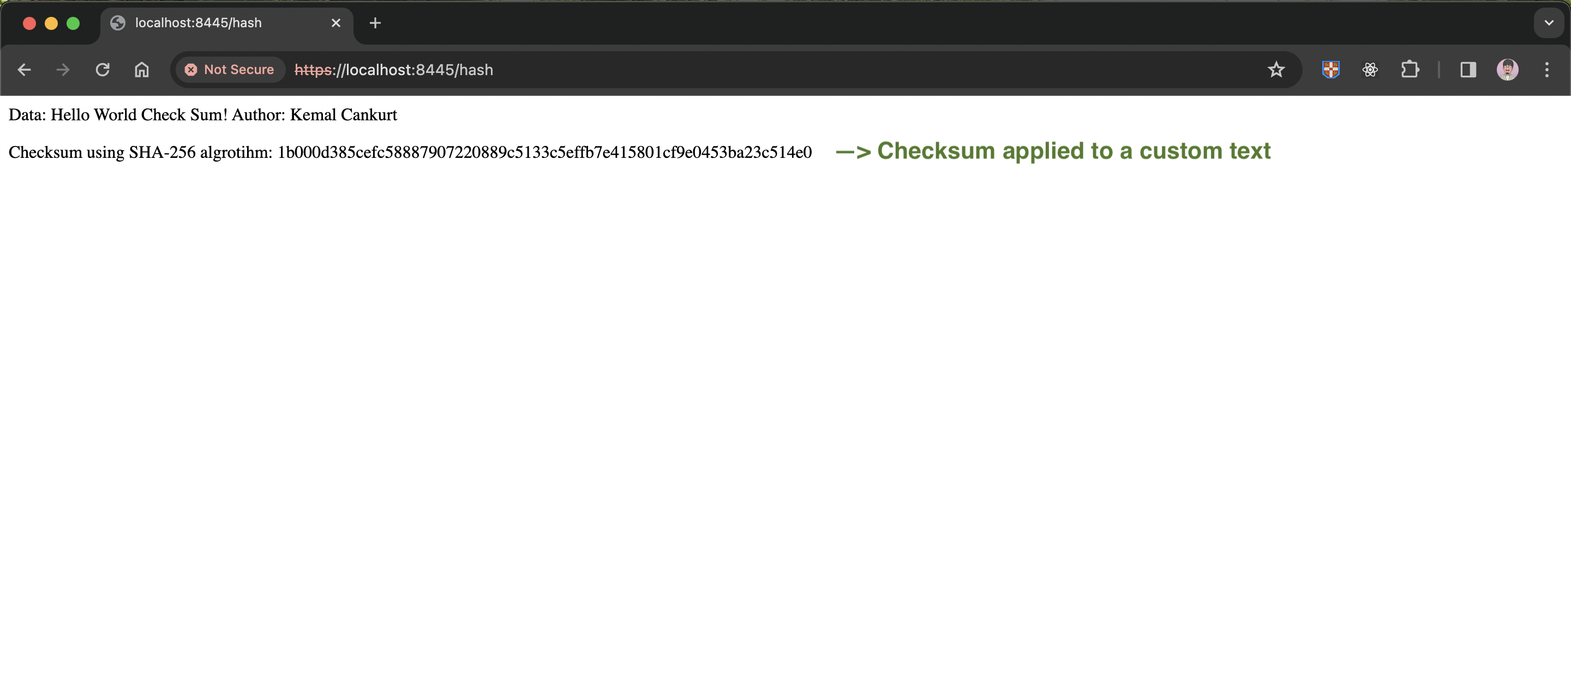

## Secure Communications

Insert a screenshot below of the web browser that shows a secure webpage.

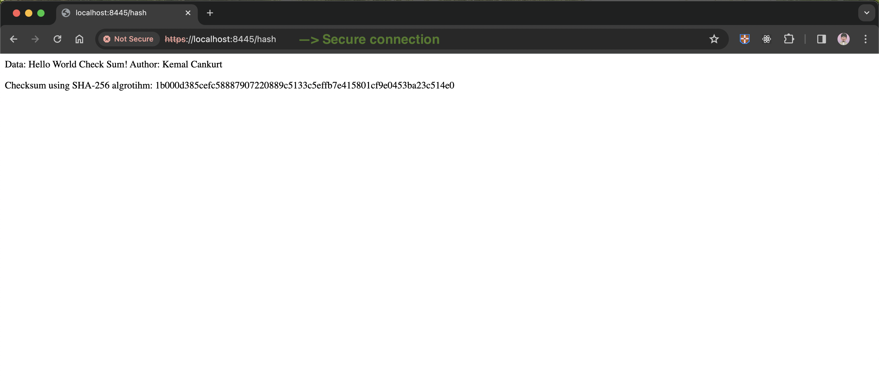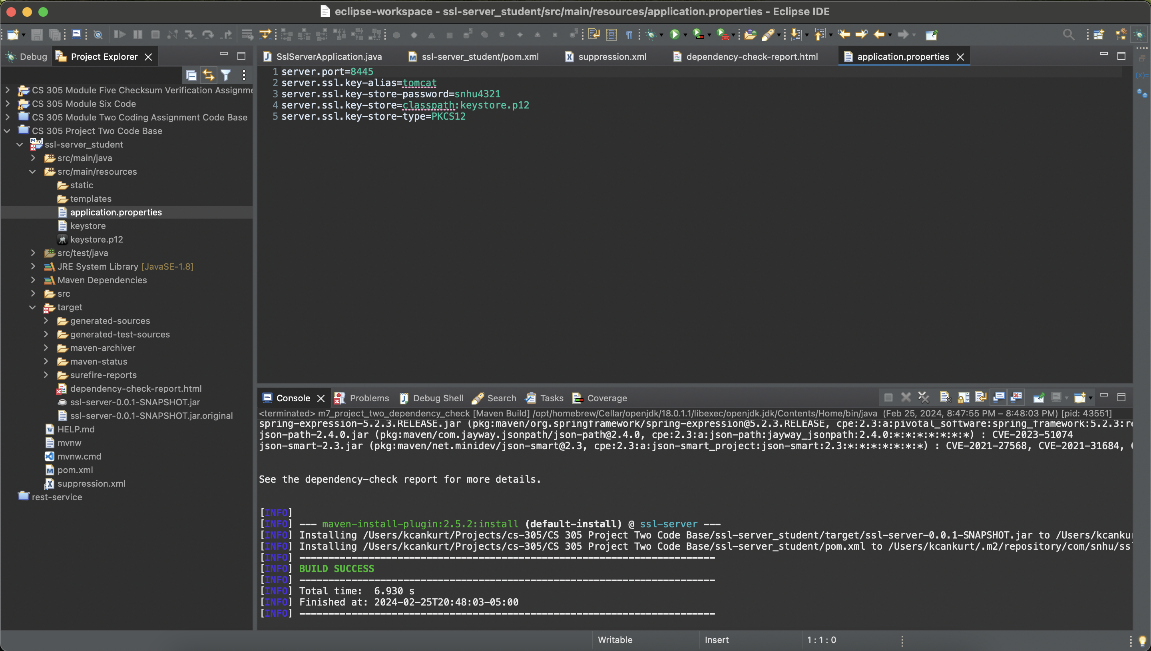

## Secondary Testing

Insert screenshots below of the refactored code executed without errors and the dependency-check report.

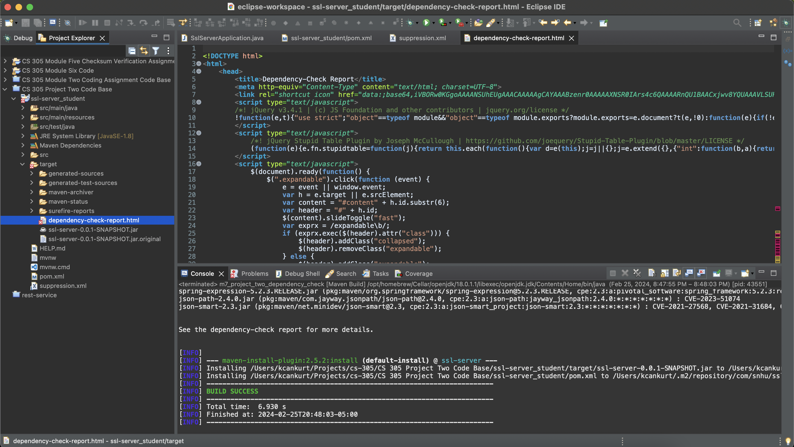

## Functional Testing

Insert a screenshot below of the refactored code executed without errors.

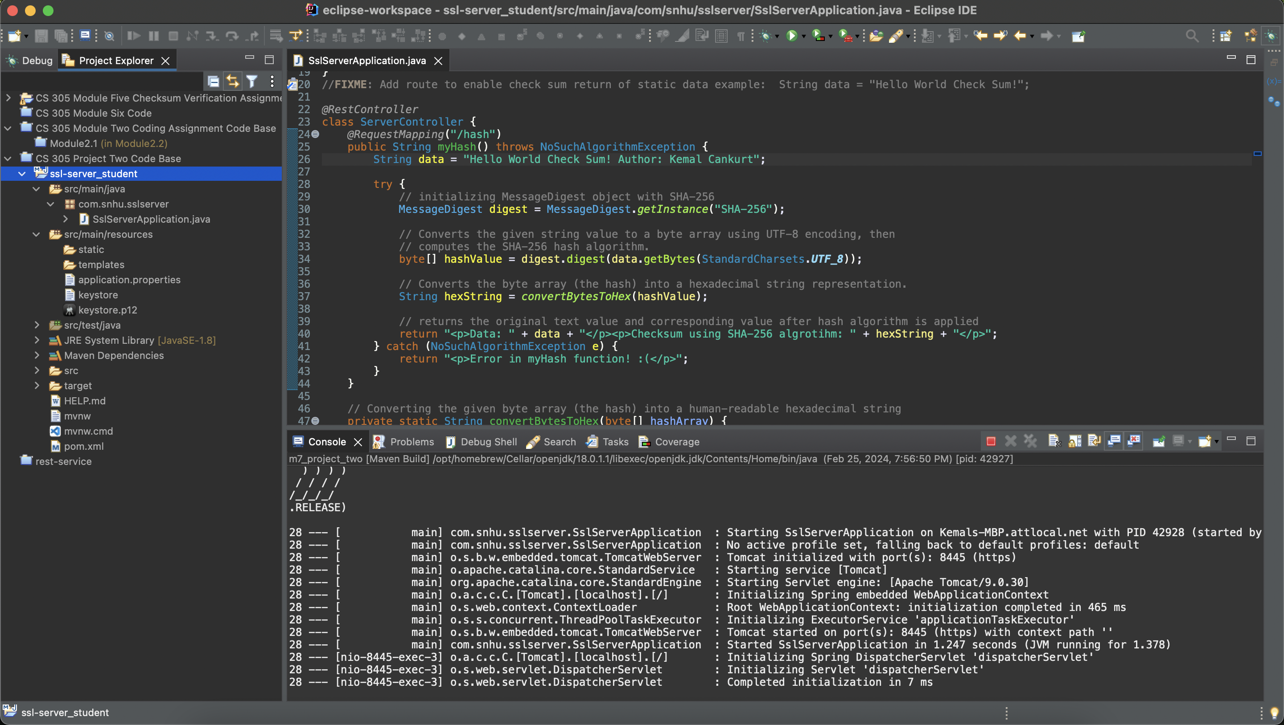

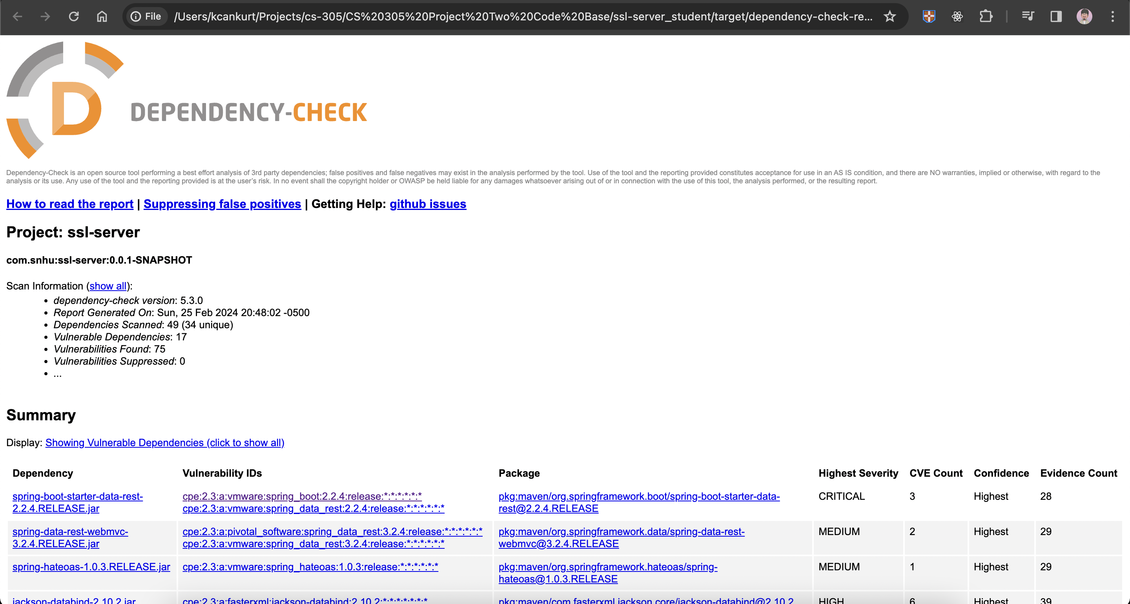

## Summary

The main objective of the code refactoring initiative was to address known vulnerabilities and bolster the security of Artemis Financials' software. The primary focus was conducting a comprehensive examination of the current codebase concerning the Vulnerability Assessment Process Flow Diagram.

Also, the AES cipher algorithm has been implemented to protect sensitive data. Java Keytool is utilized to generate a self-signed certificate to keep the development process easy yet reliable. Equally important, the checksum algorithm is implemented and demonstrated to further data security.

A multi-layered defense approach was adopted to enhance the security of the software application. Each layer was specifically tailored to handle different aspects of security threats. Through AES encryption, sensitive data is effectively safeguarded in storage and transmission. This additional layer of security ensures that the data remains inaccessible unless the correct encryption keys are used. Utilizing HTTPS protocols across all communications safeguards against intruding and most common attacks, preserving the confidentiality of data starting from taken as input through its storage. Using OWASP Dependency-Check and similar tools for vulnerability scanning of dependencies helps establish a continuous assessment layer, which assists in identifying and mitigating new vulnerabilities.

## Industry Standard Best Practices

By employing tools like OWASP Dependency-Check, developers can adopt a proactive approach to identify and mitigate these vulnerabilities, establishing a solid foundation for secure coding practices. Implementing AES (Advanced Encryption Standard) for data encryption and combining it with HTTPS protocol for secure communication ensures data security, one of the inevitable approaches in today's development standards.

## **References**

Manico, J., & Detlefsen, A. (2014, September). Iron-clad Java. O’Reilly Online Learning. <https://learning.oreilly.com/library/view/iron-clad-java/9780071835886/>

Wikipedia contributors. (2024, January 24). Advanced Encryption Standard. In Wikipedia, The Free Encyclopedia.

<https://en.wikipedia.org/w/index.php?title=Advanced_Encryption_Standard&oldid=1198496006>